Okehampton CC
Presents

10 Mile Time Trial
(Promoted for and on behalf of Cycle Time Trials under their Rules & Regulations)
Sunday 3rd July 2022
Incorporating South West District 10 Championship

Course: S40/10 Race Starts at: 07:01

Event Secretary: Timekeepers: Rob Barrow & Ian Myers
Josh Coyne
44 Roman Avenue Marshalls: Members of OKCC
Exeter
EX1 3UU Event HQ: Pump & Pedal
Tel: 07506344981 Sourton Down
On the day contact – 01837 861488 Devon
Opens at 06:00 EX20 4HT
joshcoyne@hotmail.co.uk

Awards: (One Rider, one Prize; not including team prize)

1st Male: £20 2nd Male: £10 3rd Male: £5
1st Female: £20 2nd Female: £10 3rd Female: £5

1st Male Road Bike: £10 1st Female Road Bike: £10

1st Male Vet 40-49: £10 1st Female Vet 40-49: £10
1st Male Vet 50-59: £10 1st Female Vet 50-59: £10
1st Male Vet 60-69: £10 1st Female Vet 60-69: £10

1st Junior Male: £10 1st Junior Female: £10

1st Team Overall (3 members) £30

Course Details: S40/10

Start: On the A30 approximately 2.1 miles to the West of Sourton Junction (4.7miles West of Okehampton) at the West end of the public lay-by, at a point level with the solar panel mast marked TME5023. Proceed West to Stowford Cross and filter left into the slip road signposted Broadwoodwidger. NB: this slip road is for TWO WAY TRAFFIC, so keep left of centre line. With care, turn right at the top of the slip road and proceed over bridge, crossing the dual carriageway, taking the first left into the slip road to rejoin the A30 Eastbound. EXTREME care is needed when entering the carriageway as there is NO filtering lane. Riders are advised to approach slowly, look right for traffic and keep to the nearside white line. Continue on the A30 Eastbound towards Sourton Junction. Finish on the carriageway at a point level with the fourth bollard from the West end of the public lay-by situated before the first overbridge from the turn (GR SX 481903). Distance from start to top of slip road at turn approx 5.88.

Allow 10 minutes to reach the start from HQ

Headquarters: At The Pump & Pedal Cafe/Cycle Shop, based at Sourton, EX20 4HT, where toilet facilities are available. Refreshments will be available from approx 0600. Parking is available in the car park outside the Shop and further parking is available down the entry road, along the GREEN line marked on the attached map. Please park considerately and do not park on the other side of the road, you may well be asked (politely) to move if you do. Thank you.

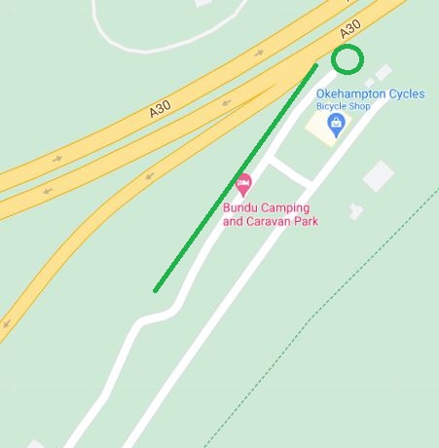

Notes to all Riders:

***It is COMPULSORY that a WORKING FRONT AND REAR LIGHT, either flashing or constant, is fitted to the machine in a position visible to following road users and is active while the machine is in use. ***
***It is now COMPULSORY that a HARD-SHELL HELMET that meets an internationally accepted safety standard is to be worn. ***

You must return to the HQ after your ride and sign out.

Although we are using disposable numbers, please return them to the HQ after your ride.

Do not stop at the finish to ask for times. Continue back to the HQ and await results.

The S40/10 course is on a high speed road. Overtaking traffic will be moving fast. For your own safety keep well to the left and as close to the fog line as possible. (1M Max)

Please observe the Highway Code. Ride with your head up, and do not white line. You must have a working rear light fitted to your machine. It is also advisable to wear bright clothing.

In the interests of your own safety, Cycling Time Trials and the event promoters strongly advise riders to wear a HARD SHELL HELMET that meets an approved international safety standard.

The risk assessment form and signing on sheets will be on the table at the front of the HQ. When signing on please look to see if there are any safety notes on the risk assessment form added after the pre race course inspection.

Please remember that event officials have no legal right to interfere with or regulate traffic.

Please call out your number loud and clear at the finish line.

CTT Requires all riders to be aware of, and observe the rules applying to company riding and slipstreaming.

Sponsored Clubs:
As per the Startsheet.

Thank you for your support of our event, and we wish you a safe and successful morning of racing.

